SECURITIES AND EXCHANGE COMMISSION

Washington, D.C. 20549

SCHEDULE 13G

Under the Securities Exchange Act of 1934

(Amendment No. __)

(Rule 13d-102)

INFORMATION TO BE INCLUDED IN STATEMENTS FILED PURSUANT TO RULES 13d-1(b), (c) AND (d)

AND AMENDMENTS THERETO FILED PURSUANT TO RULE 13d-2(b)

Under the Securities Exchange Act of 1934

BACKBLAZE, INC.

(Name of Issuer)

Class A Common Stock, $0.0001 par value per share

(Title of Class of Securities)

05637B105

(CUSIP Number)

November 11, 2021

(Date of Event Which Requires Filing of this Statement)

Check the appropriate box to designate the rule pursuant to which this Schedule is filed:

- Rule 13d-1(b)

- Rule 13d-1(c)

  - Rule 13d-1(d)

* The remainder of this cover page shall be filled out for a reporting person’s initial filing on this form with respect to the subject class of securities, and for any subsequent amendment containing information which would alter the disclosures provided in a prior cover page.

The information required in the remainder of this cover page shall not be deemed to be "filed" for the purpose of Section 18 of the Securities Exchange Act of 1934 ("Act") or otherwise subject to the liabilities of that section of the Act but shall be subject to all other provisions of the Act (however, see the Notes).

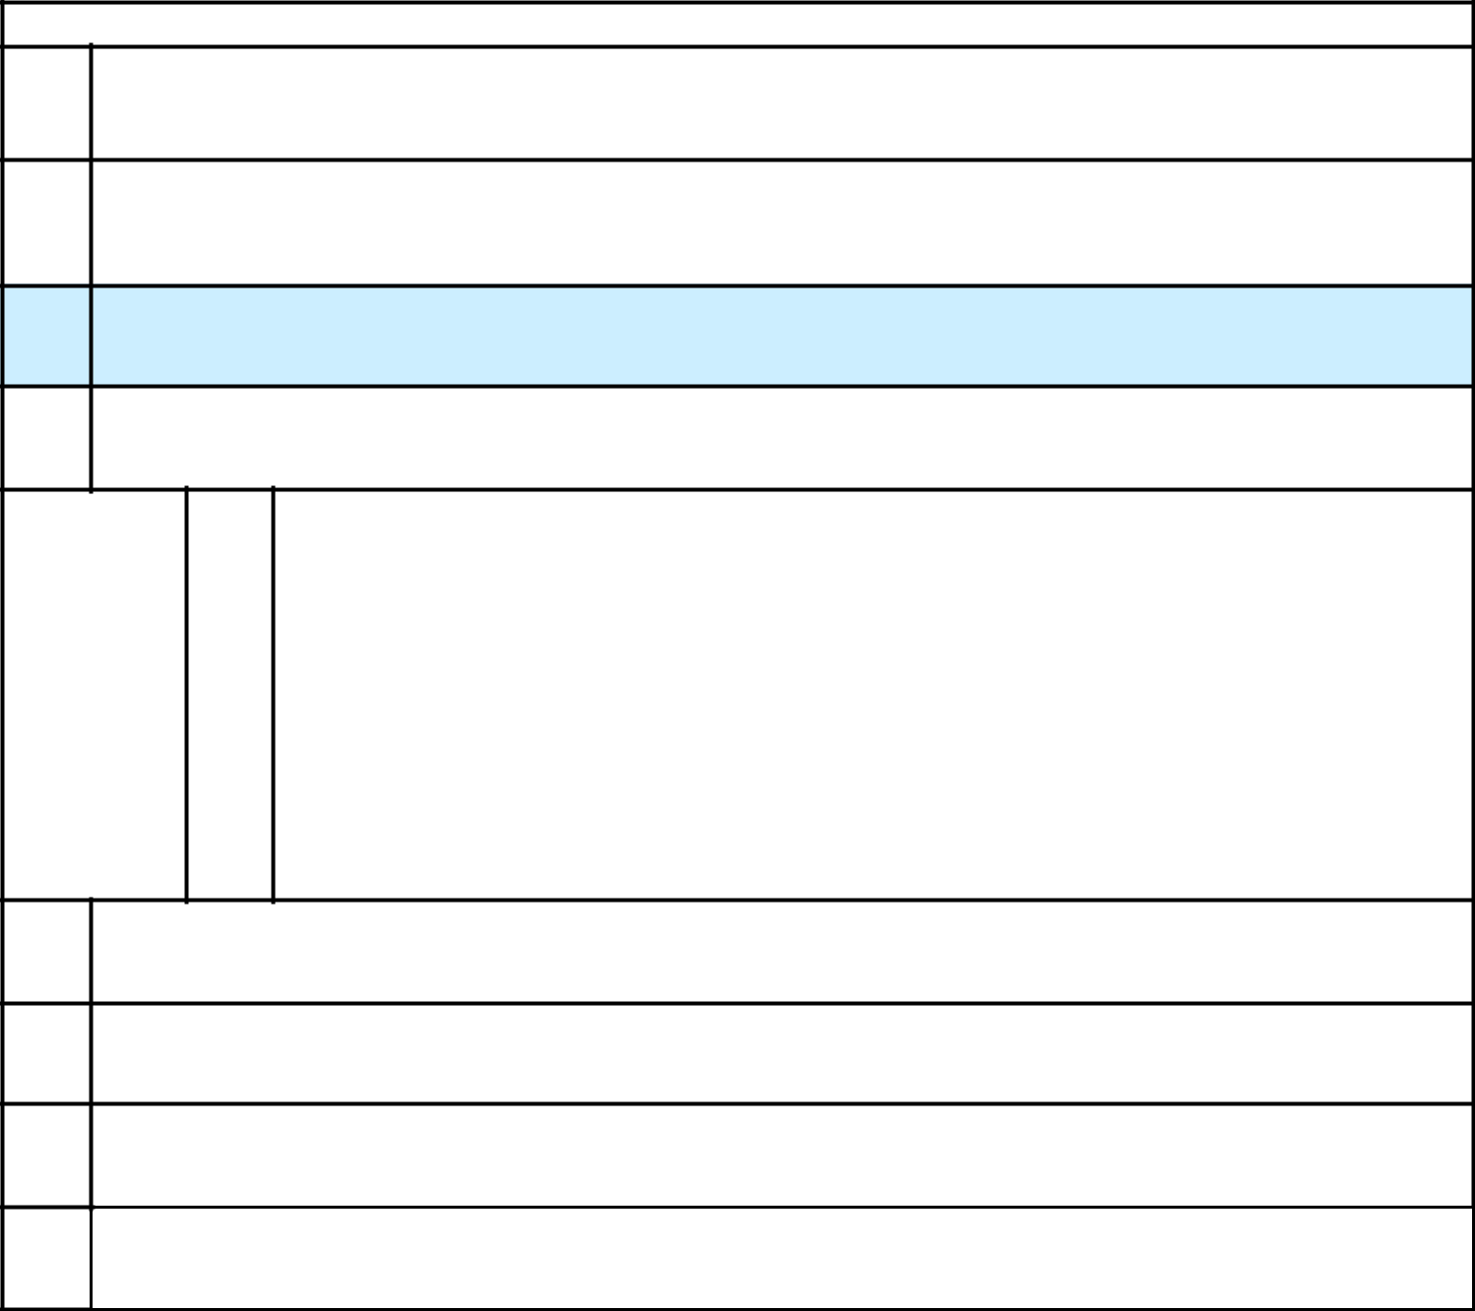
CUSIP NO. 05637B105

- Name of Reporting Persons/

I.R.S. Identification Nos. of above persons (entities only). Clal Insurance Enterprises Holdings Ltd.
- Check the Appropriate Box if a Member of a Group

  - ☐

  - ☐

- SEC Use only

- Place of Organization Israel

    - Sole Voting Power

 |  | 0
Number of
 | 6. | Shared Voting Power
Shares
Beneficially |  | 1,150,568 shares of Class A Common Stock *
Owned
 | 7. | Sole Dispositive Power
by Each
Reporting |  | 0
Person With:
 | 8. | Shared Dispositive Power

1,150,568 shares of Class A Common Stock *

- Aggregate Amount Beneficially Owned by Each Reporting Person

1,150,568 shares of Class A Common Stock *

- Check if the Aggregate Amount in Row (9) Excludes Certain Shares

☐

- Percent of Class Represented by Amount in Row (9)

7.6%**

  - Type of Reporting Person :

CO

* See Item 4.

- Based on 15,108,346 shares of Class A Common Stock outstanding as of September 30, 2022 (as reported by the Issuer in its report on Form 10-Q submitted to the Securities and Exchange Commission on November 10, 2022).

EXPLANATORY NOTE

This Schedule 13G is filed by the Reporting Person (as defined below) pursuant to Rule 13d-1(c) in connection with initial public offering of the Issuer (as defined below) and commencement of trading of its Class A Common Stock on the NASDAQ Global Market on November 11, 2021, which means that the “Date of Event Which Requires Filing of this Statement” is November 11, 2021 (the “Initial Date”) and that the due date for filing this Schedule 13G pursuant to Rule 13d-1(c) was November 22, 2021. However, due to a technical error, the Reporting Person did not file the Schedule 13G by that time and is filing this Schedule 13G on the date hereof. As shown in Item 4 below, the information with respect to the beneficial ownership of shares of Class A Common Stock by the Reporting Person is provided as of the Initial Date, December 31, 2021 and as of October 31, 2022.

Item 1.

- Name of Issuer: BACKBLAZE, INC. (the “Issuer”).

- Address of Issuer’s Principal Executive Offices:

500 Ben Franklin Ct., San Mateo, California 94401

Item 2.

- Name of Person Filing:

Clal Insurance Enterprises Holdings Ltd. (“Clal” or the “Reporting Person”). Clal, an Israeli public corporation, may be deemed to beneficially own the shares of Class A Common Stock reported in this Statement. See Item 4.

- Address of Principal Business Offices or, if none, Residence:

Clal Insurance Enterprises Holdings Ltd. – 36 Raul Walenberg St., Tel Aviv 66180, Israel

- Place of Organization:

Israel.

- Title of Class of Securities:

Class A Common Stock, $0.0001 par value per share (the “Class A Common Stock”).

- CUSIP Number:

05637B105

Item 3. If this statement is filed pursuant to Rules 13d-1(b), or 13d-2(b) or (c), check whether the person filing is a:

Not applicable.

Item 4. Ownership

As of October 31, 2022: The Reporting Person may be deemed to beneficially own 1,150,568 shares of Class A Common Stock as of October 31, 2022. All of the 1,150,568 shares of Class A Common Stock reported in this Statement as beneficially owned by Clal as of such date are held for members of the public through, among others, provident funds and/or pension funds and/or insurance policies, which are managed by subsidiaries of Clal, which subsidiaries operate under independent management and make independent voting and investment decisions. Consequently, this Statement shall not be construed as an admission by Clal, that it is the beneficial owner of any of the shares of Class A Common Stock covered by this Statement.

Except as set forth above, see items 5-11 of the cover page hereto for beneficial ownership, percentage of class and dispositive power of the Reporting Person, which are incorporated herein.

As of December 31, 2021: The Reporting Person may be deemed to beneficially own 1,026,567 shares of Class A Common Stock as of December 31, 2021. All of the 1,026,567 shares of Class A Common Stock reported in this Statement as beneficially owned by Clal as of such date are held for members of the public through, among others, provident funds and/or pension funds and/or insurance policies, which are managed by subsidiaries of Clal, which subsidiaries operate under independent management and make independent voting and investment decisions. Consequently, this Statement shall not be

construed as an admission by Clal, that it is the beneficial owner of any of the shares of Class A Common Stock covered by this Statement.

As of November 11, 2021: The Reporting Person may be deemed to beneficially own 586,252 shares of Class A Common Stock as of November 11, 2021. All of the 586,252 Class A Common Stock reported in this Statement as beneficially owned by Clal as of such date are held for members of the public through, among others, provident funds and/or pension funds and/or insurance policies, which are managed by subsidiaries of Clal, which subsidiaries operate under independent management and make independent voting and investment decisions. Consequently, this Statement shall not be construed as an admission by Clal, that it is the beneficial owner of any of the shares of Class A Common Stock covered by this Statement.

Item 5. Ownership of 5 Percent or Less of a Class

If this statement is being filed to report the fact that as of the date hereof the reporting person has ceased to be the beneficial owner of more than 5 percent of the class of securities, check the following ☐.

Item 6. Ownership of More than 5 Percent on Behalf of Another Person

Not applicable.

Item 7. Identification and Classification of the Subsidiary Which Acquired the Security Being Reported on by the Parent Holding Company or Control Person

Not applicable.

Item 8. Identification and Classification of Members of the Group

Not applicable.

Item 9. Notice of Dissolution of GroupNot applicable.

Item 10. Certifications

By signing below I certify that, to the best of my knowledge and belief, the securities referred to above were not acquired and are not held for the purpose of or with the effect of changing or influencing the control of the issuer of the securities and were not acquired and are not held in connection with or as a participant in any transaction having that purpose or effect, other than activities solely in connection with a nomination under §240.14a-11.

SIGNATURES

After reasonable inquiry and to the best of my knowledge and belief, I certify that the information set forth in this statement is true, complete and correct.

November 14, 2022

CLAL INSURANCE ENTERPRISES HOLDINGS LTD.

By: /s/ Eran Czerninski /s/ Yossi Dory

Eran Czerninski and Yossi Dory, authorized signatories of

CLAL INSURANCE ENTERPRISES HOLDINGS LTD.

