SEC Form 4

FORM 4

Check this box if no longer subject to Section 16. Form 4 or Form 5 obligations may continue. See Instruction 1(b).

UNITED STATES SECURITIES AND EXCHANGE COMMISSION
Washington, D.C. 20549
 |  | OMB APPROVAL
STATEMENT OF CHANGES IN BENEFICIAL OWNERSHIP
 |  | OMB Number: | 3235-0287
 |  | Estimated average burden
Filed pursuant to Section 16(a) of the Securities Exchange Act of 1934 |  | hours per response: | 0.5
or Section 30(h) of the Investment Company Act of 1940
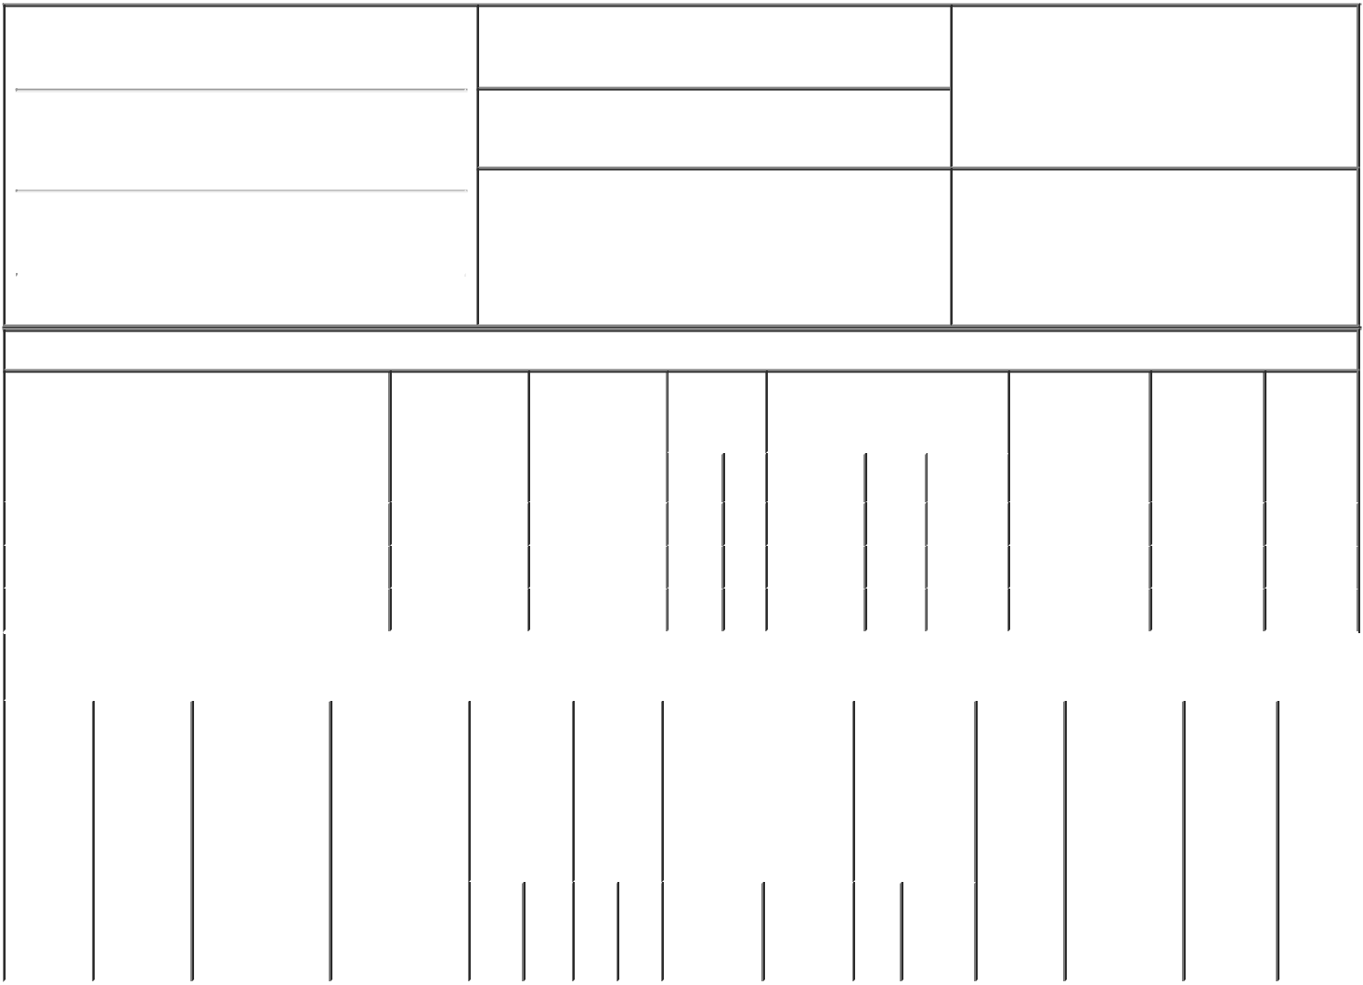

1. Name and Address of Reporting Person*
Nufire Timothy M

(Last) (First) (Middle)

500 BEN FRANKLIN CT.

2. Issuer Name and Ticker or Trading Symbol

Backblaze, Inc. [ BLZE ]

3. Date of Earliest Transaction (Month/Day/Year)

08/09/2022

- Relationship of Reporting Person(s) to Issuer (Check all applicable)
X Director X 10% Owner

Officer (give title Other (specify

below) below)

(Street)
 | SAN MATEO | CA | 94401
 | (City) | (State) | (Zip)

4. If Amendment, Date of Original Filed (Month/Day/Year) 6. Individual or Joint/Group Filing (Check Applicable

Line)

X Form filed by One Reporting Person

Form filed by More than One Reporting

Person

Table I - Non-Derivative Securities Acquired, Disposed of, or Beneficially Owned

 | 1. Title of Security (Instr. 3) |  |  | 2. Transaction |  | 2A. Deemed |  | 3. | 4. Securities Acquired (A) or |  |  |  |  |  | 5. Amount of |  | 6. Ownership | 7. Nature
 |  |  |  | Date |  | Execution Date, |  | Transaction | Disposed Of (D) (Instr. 3, 4 and |  |  |  |  |  | Securities |  | Form: Direct | of Indirect
 |  |  |  | (Month/Day/Year) |  | if any |  | Code (Instr. | 5) |  |  |  |  |  | Beneficially |  | (D) or Indirect | Beneficial
 |  |  |  |  |  | (Month/Day/Year) |  | 8) |  |  |  |  |  |  | Owned Following |  | (I) (Instr. 4) | Ownership
 |  |  |  |  |  |  |  |  |  |  |  |  |  |  | Reported |  |  | (Instr. 4)
 |  |  |  |  |  |  |  | Code V | Amount | (A) or |  | Price |  |  | Transaction(s)
 |  |  |  |  |  |  |  |  |  | (D) |  |  |  |  | (Instr. 3 and 4)
 | Class A Common Stock |  |  | 08/09/2022 |  |  |  | _{S}(1) | 2,000 | D |  | $6.73⁽²⁾ |  |  | 438,000 |  | D
 | Class A Common Stock |  |  | 08/10/2022 |  |  |  | _{S}(1) | 2,000 | D |  |  | _{$7}(3) |  | 436,000 |  | D
 | Class A Common Stock |  |  | 08/11/2022 |  |  |  | _{S}(1) | 2,000 | D |  | $7.56⁽⁴⁾ |  |  | 434,000 |  | D
 |  |  | Table II - Derivative Securities Acquired, Disposed of, or Beneficially Owned
 |  |  |  | (e.g., puts, calls, warrants, options, convertible securities)
 | 1. Title of | 2. | 3. Transaction | 3A. Deemed | 4. |  | 5. Number | 6. Date Exercisable and |  | 7. Title and |  |  |  | 8. Price of |  | 9. Number of 10. |  | 11. Nature
 | Derivative | Conversion | Date | Execution Date, | Transaction |  | of | Expiration Date |  | Amount of |  |  |  | Derivative |  | derivative | Ownership | of Indirect
 | Security | or Exercise | (Month/Day/Year) | if any | Code (Instr. |  | Derivative | (Month/Day/Year) |  | Securities |  |  |  | Security |  | Securities | Form: | Beneficial
 | (Instr. 3) | Price of |  | (Month/Day/Year) | 8) |  | Securities |  |  | Underlying |  |  |  | (Instr. 5) |  | Beneficially | Direct (D) | Ownership
 |  | Derivative |  |  |  |  | Acquired |  |  | Derivative |  |  |  |  |  | Owned | or Indirect | (Instr. 4)
 |  | Security |  |  |  |  | (A) or |  |  | Security (Instr. |  |  |  |  |  | Following | (I) (Instr. 4)
 |  |  |  |  |  |  | Disposed |  |  | 3 and 4) |  |  |  |  |  | Reported
 |  |  |  |  |  |  | of (D) |  |  |  |  |  |  |  |  | Transaction(s)
 |  |  |  |  |  |  | (Instr. 3, 4 |  |  |  |  |  |  |  |  | (Instr. 4)
 |  |  |  |  |  |  | and 5)
 |  |  |  |  |  |  |  |  |  |  | Amount
 |  |  |  |  |  |  |  |  |  |  | or
 |  |  |  |  |  |  |  |  |  |  | Number
 |  |  |  |  |  |  |  | Date | Expiration |  | of
 |  |  |  |  | Code | V | (A) (D) | Exercisable | Date | Title | Shares

Explanation of Responses:

- The sales reported were effected pursuant to a Rule 10b5-1 trading plan adopted by the Reporting Person.

- The price reported is a weighted average price. These shares were sold in multiple transactions at prices ranging from $6.63 to $6.92, inclusive. The Reporting Person undertakes to provide to the Issuer, any security holder of the Issuer, or the Securities and Exchange Commission, upon request, full information regarding the number of shares sold at each separate price within the ranges set forth herein.

- The price reported is a weighted average price. These shares were sold in multiple transactions at prices ranging from $6.75 to $7.185, inclusive. The Reporting Person undertakes to provide to the Issuer, any security holder of the Issuer, or the Securities and Exchange Commission, upon request, full information regarding the number of shares sold at each separate price within the ranges set forth herein.

- The price reported is a weighted average price. These shares were sold in multiple transactions at prices ranging from $7.20 to $7.75, inclusive. The Reporting Person undertakes to provide to the Issuer, any security holder of the Issuer, or the Securities and Exchange Commission, upon request, full information regarding the number of shares sold at each separate price within the ranges set forth herein.

Remarks:

/s/ Thomas MacMitchell - |  |  | 08/11/2022
Attorney-in-Fact
** Signature of Reporting Person |  |  | Date

Reminder: Report on a separate line for each class of securities beneficially owned directly or indirectly.

* If the form is filed by more than one reporting person, see Instruction 4 (b)(v).

- Intentional misstatements or omissions of facts constitute Federal Criminal Violations See 18 U.S.C. 1001 and 15 U.S.C. 78ff(a). Note: File three copies of this Form, one of which must be manually signed. If space is insufficient, see Instruction 6 for procedure.

Persons who respond to the collection of information contained in this form are not required to respond unless the form displays a currently valid OMB Number.

