SEC Form 4

FORM 4

Check this box if no longer subject to Section 16. Form 4 or Form 5 obligations may continue. See Instruction 1(b).

UNITED STATES SECURITIES AND EXCHANGE COMMISSION
Washington, D.C. 20549
 |  | OMB APPROVAL
STATEMENT OF CHANGES IN BENEFICIAL OWNERSHIP
 |  | OMB Number: | 3235-0287
 |  | Estimated average burden
Filed pursuant to Section 16(a) of the Securities Exchange Act of 1934 |  | hours per response: | 0.5
or Section 30(h) of the Investment Company Act of 1940
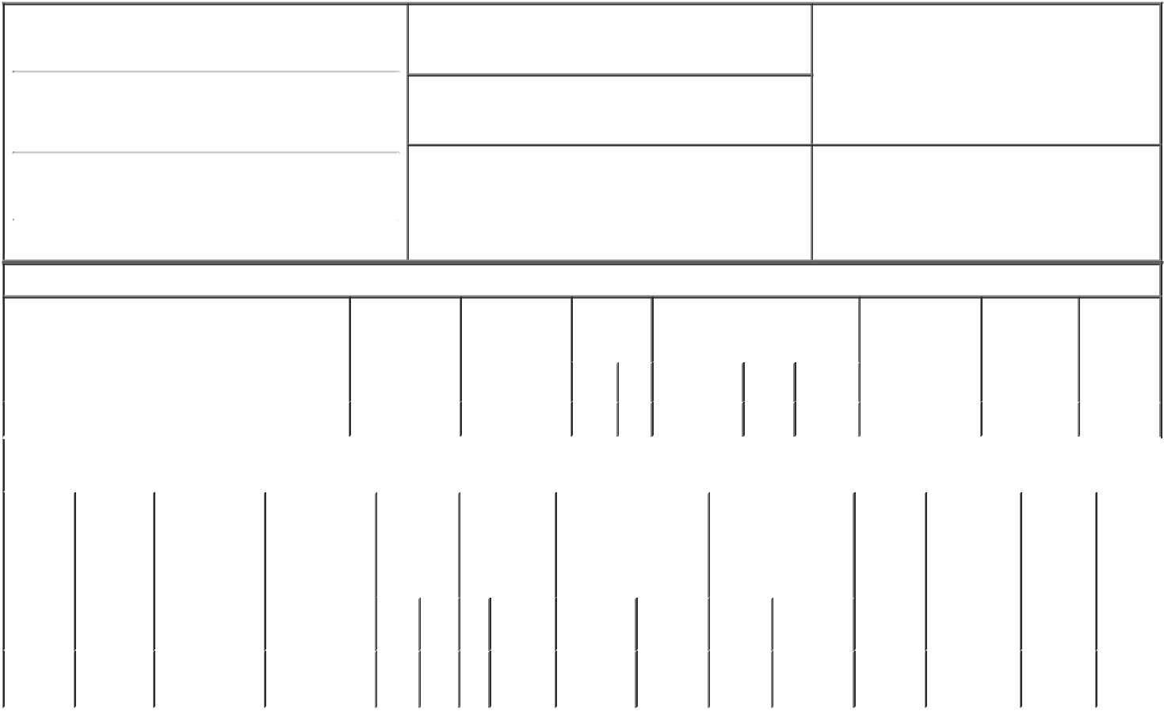

1. Name and Address of Reporting Person*
Jones Charles J.

(Last) (First) (Middle)

500 BEN FRANKLIN CT.

2. Issuer Name and Ticker or Trading Symbol
Backblaze, Inc. [ BLZE ]

3. Date of Earliest Transaction (Month/Day/Year)

02/21/2023

- Relationship of Reporting Person(s) to Issuer (Check all applicable)

Director X 10% Owner

Officer (give title Other (specify
below) below)

(Street)
 | SAN MATEO | CA | 94401
 | (City) | (State) | (Zip)

4. If Amendment, Date of Original Filed (Month/Day/Year) 6. Individual or Joint/Group Filing (Check Applicable
Line)
X Form filed by One Reporting Person

Form filed by More than One Reporting Person

Table I - Non-Derivative Securities Acquired, Disposed of, or Beneficially Owned

 | 1. Title of Security (Instr. 3) |  |  | 2. Transaction |  |  | 2A. Deemed | 3. |  | 4. Securities Acquired (A) or |  |  |  |  |  | 5. Amount of |  | 6. Ownership |  | 7. Nature of
 |  |  |  | Date |  |  | Execution Date, |  | Transaction Disposed Of (D) (Instr. 3, 4 and 5) |  |  |  |  |  |  | Securities |  | Form: Direct |  | Indirect
 |  |  |  | (Month/Day/Year) |  |  | if any |  | Code (Instr. |  |  |  |  |  |  | Beneficially |  | (D) or Indirect |  | Beneficial
 |  |  |  |  |  |  | (Month/Day/Year) 8) |  |  |  |  |  |  |  |  | Owned Following |  | (I) (Instr. 4) |  | Ownership
 |  |  |  |  |  |  |  |  |  |  |  |  |  |  |  | Reported |  |  |  | (Instr. 4)
 |  |  |  |  |  |  |  |  | Code V | Amount |  | (A) or |  | Price |  | Transaction(s)
 |  |  |  |  |  |  |  |  |  |  |  | (D) |  |  |  | (Instr. 3 and 4)
 | Class A Common Stock |  |  | 02/21/2023 |  |  |  |  | M | 1,000,000 |  | A |  | $0 |  | 1,168,000 |  |  | D
 |  |  |  | Table II - Derivative Securities Acquired, Disposed of, or Beneficially Owned
 |  |  |  | (e.g., puts, calls, warrants, options, convertible securities)
 | 1. Title of | 2. | 3. Transaction | 3A. Deemed |  | 4. | 5. Number of | 6. Date Exercisable and |  |  | 7. Title and Amount of |  |  |  |  | 8. Price of | 9. Number of |  | 10. | 11. Nature
 | Derivative | Conversion | Date | Execution Date, |  | Transaction | Derivative | Expiration Date |  |  | Securities Underlying |  |  |  |  | Derivative | derivative |  | Ownership of Indirect
 | Security | or Exercise | (Month/Day/Year) | if any |  | Code (Instr. | Securities | (Month/Day/Year) |  |  | Derivative Security |  |  |  |  | Security | Securities |  | Form: | Beneficial
 | (Instr. 3) | Price of |  | (Month/Day/Year) |  | 8) | Acquired (A) |  |  |  | (Instr. 3 and 4) |  |  |  |  | (Instr. 5) | Beneficially |  | Direct (D) | Ownership
 |  | Derivative |  |  |  |  | or Disposed of |  |  |  |  |  |  |  |  |  | Owned |  | or Indirect | (Instr. 4)
 |  | Security |  |  |  |  | (D) (Instr. 3, 4 |  |  |  |  |  |  |  |  |  | Following |  | (I) (Instr. 4)
 |  |  |  |  |  |  | and 5) |  |  |  |  |  |  |  |  |  | Reported
 |  |  |  |  |  |  |  |  |  |  |  |  |  |  |  |  | Transaction(s)
 |  |  |  |  |  |  |  |  |  |  |  |  | Amount or |  |  |  | (Instr. 4)
 |  |  |  |  |  |  |  | Date |  | Expiration |  |  | Number of
 |  |  |  |  |  | Code V | (A) (D) | Exercisable |  | Date | Title |  | Shares
 | Class B | (1) |  |  |  |  |  | (1) |  | (1) | Class A |  | 1,000,000
 | Common |  | 02/21/2023 |  |  | M | 1,000,000 |  |  |  | Common |  |  |  |  | $0 | 1,265,121 |  | D
 | Stock |  |  |  |  |  |  |  |  |  | Stock

Explanation of Responses:

1. Each share of Class B Common Stock is convertible into one share of Class A Common Stock at any time at the option of the Reporting Person and has no expiration date.

Remarks:

/s/ Thomas MacMitchell - |  |  | 02/23/2023
Attorney-in-Fact
** Signature of Reporting Person |  |  | Date

Reminder: Report on a separate line for each class of securities beneficially owned directly or indirectly.

* If the form is filed by more than one reporting person, see Instruction 4 (b)(v).

- Intentional misstatements or omissions of facts constitute Federal Criminal Violations See 18 U.S.C. 1001 and 15 U.S.C. 78ff(a). Note: File three copies of this Form, one of which must be manually signed. If space is insufficient, see Instruction 6 for procedure.
Persons who respond to the collection of information contained in this form are not required to respond unless the form displays a currently valid OMB Number.

