SEC Form 4

FORM 4

Check this box if no longer subject to Section 16. Form 4 or Form 5 obligations may continue. See Instruction 1(b).

UNITED STATES SECURITIES AND EXCHANGE COMMISSION
Washington, D.C. 20549
 |  | OMB APPROVAL
STATEMENT OF CHANGES IN BENEFICIAL OWNERSHIP
 |  | OMB Number: | 3235-0287
 |  | Estimated average burden
Filed pursuant to Section 16(a) of the Securities Exchange Act of 1934 |  | hours per response: | 0.5
or Section 30(h) of the Investment Company Act of 1940
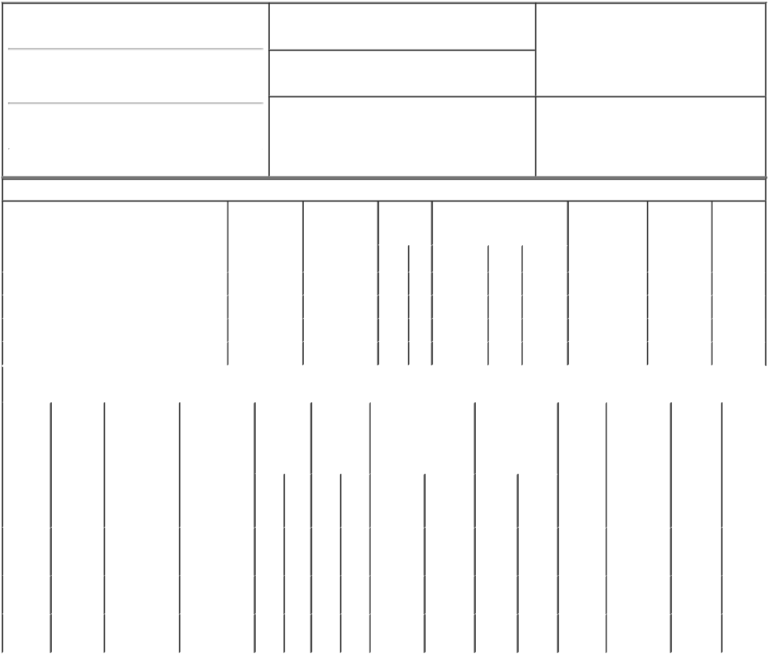

1. Name and Address of Reporting Person*
Patchel Francis P

(Last) (First) (Middle)

500 BEN FRANKLIN CT.

2. Issuer Name and Ticker or Trading Symbol

Backblaze, Inc. [ BLZE ]

3. Date of Earliest Transaction (Month/Day/Year)

08/23/2022

- Relationship of Reporting Person(s) to Issuer (Check all applicable)

 | Director | 10% Owner
X | Officer (give title | Other (specify
 | below) | below)

Chief Financial Officer

(Street)
 | SAN MATEO | CA | 94401
 | (City) | (State) | (Zip)

4. If Amendment, Date of Original Filed (Month/Day/Year) 6. Individual or Joint/Group Filing (Check Applicable

Line)
X Form filed by One Reporting Person

Form filed by More than One Reporting

Person

Table I - Non-Derivative Securities Acquired, Disposed of, or Beneficially Owned

 | 1. Title of Security (Instr. 3) |  |  | 2. Transaction |  | 2A. Deemed |  | 3. |  | 4. Securities Acquired (A) or |  |  |  |  | 5. Amount of |  | 6. Ownership |  | 7. Nature of
 |  |  |  | Date |  | Execution Date, |  |  | Transaction | Disposed Of (D) (Instr. 3, 4 and 5) |  |  |  |  | Securities |  | Form: Direct |  | Indirect
 |  |  |  | (Month/Day/Year) |  | if any |  |  | Code (Instr. |  |  |  |  |  | Beneficially |  | (D) or Indirect |  | Beneficial
 |  |  |  |  |  | (Month/Day/Year) |  | 8) |  |  |  |  |  |  | Owned Following |  | (I) (Instr. 4) |  | Ownership
 |  |  |  |  |  |  |  |  |  |  |  |  |  |  | Reported |  |  |  | (Instr. 4)
 |  |  |  |  |  |  |  |  | Code V | Amount | (A) or | Price |  |  | Transaction(s)
 |  |  |  |  |  |  |  |  |  |  | (D) |  |  |  | (Instr. 3 and 4)
 | Class A Common Stock |  |  | 08/23/2022 |  |  |  |  | _{S}(1) | 2,340 | D | $7.5⁽²⁾ |  |  | 104,789⁽³⁾ |  |  | D
 | Class A Common Stock |  |  | 11/23/2022 |  |  |  |  | _{S}(1) | 2,521 | D | $3.77 |  |  | 103,561 |  |  | D
 | Class A Common Stock |  |  | 02/01/2023 |  |  |  |  | C | 3,000 | A | $0 |  |  | 106,561 |  |  | D
 | Class A Common Stock |  |  | 02/01/2023 |  |  |  |  | _{S}(4) | 3,000 | D | $7.02⁽⁵⁾ |  |  | 103,561 |  |  | D
 |  |  |  | Table II - Derivative Securities Acquired, Disposed of, or Beneficially Owned
 |  |  |  | (e.g., puts, calls, warrants, options, convertible securities)
 | 1. Title of | 2. | 3. Transaction | 3A. Deemed | 4. | 5. Number of |  | 6. Date Exercisable and |  |  | 7. Title and |  |  | 8. Price of |  | 9. Number of |  | 10. | 11. Nature
 | Derivative | Conversion | Date | Execution Date, | Transaction | Derivative |  | Expiration Date |  |  | Amount of |  |  | Derivative |  | derivative |  | Ownership of Indirect
 | Security | or Exercise | (Month/Day/Year) | if any | Code (Instr. | Securities |  | (Month/Day/Year) |  |  | Securities |  |  | Security |  | Securities |  | Form: | Beneficial
 | (Instr. 3) | Price of |  | (Month/Day/Year) | 8) | Acquired (A) |  |  |  |  | Underlying |  |  | (Instr. 5) |  | Beneficially |  | Direct (D) | Ownership
 |  | Derivative |  |  |  | or Disposed |  |  |  |  | Derivative Security |  |  |  |  | Owned |  | or Indirect | (Instr. 4)
 |  | Security |  |  |  | of (D) (Instr. |  |  |  |  | (Instr. 3 and 4) |  |  |  |  | Following |  | (I) (Instr. 4)
 |  |  |  |  |  | 3, 4 and 5) |  |  |  |  |  |  |  |  |  | Reported
 |  |  |  |  |  |  |  |  |  |  |  |  |  |  |  | Transaction(s)
 |  |  |  |  |  |  |  |  |  |  |  | Amount |  |  |  | (Instr. 4)
 |  |  |  |  |  |  |  |  |  |  |  | or
 |  |  |  |  |  |  |  |  |  |  |  | Number
 |  |  |  |  |  |  |  | Date |  | Expiration |  | of
 |  |  |  |  | Code V | (A) | (D) | Exercisable |  | Date | Title | Shares
 | Stock |  |  |  |  |  |  |  |  |  | Class B
 | Option |  |  |  |  |  |  | (6) |  |  |  | 3,000
 |  | $2.61 | 02/01/2023 |  | M |  | 3,000 |  |  | 04/20/2030 | Common |  |  |  | $0 | 278,060 |  | D
 | (right to
 |  |  |  |  |  |  |  |  |  |  | Stock
 | buy)
 | Class B | (7) |  |  |  |  |  | (7) |  | (7) | Class A | 3,000
 | Common |  | 02/01/2023 |  | M | 3,000 |  |  |  |  | Common |  |  |  | $0 | 3,000 |  | D
 | Stock |  |  |  |  |  |  |  |  |  | Stock
 | Class B | (7) |  |  |  |  |  | (7) |  | (7) | Class A | 3,000
 | Common |  | 02/01/2023 |  | C |  | 3,000 |  |  |  | Common |  |  |  | $0 | 0 |  | D
 | Stock |  |  |  |  |  |  |  |  |  | Stock

Explanation of Responses:

- The sales reported on this Form 4 represent shares required to be sold by the Reporting Person to cover tax withholding obligations in connection with the vesting and settlement of restricted stock units. These sales are mandated by the Issuer's election under its equity incentive plans to require the satisfaction of tax withholding obligations to be funded by a "sell to cover" transaction and do not represent discretionary trades by the Reporting Person.

- The price reported is a weighted average price. These shares were sold in multiple transactions at prices ranging from $7.486 to $7.509, inclusive. The Reporting Person undertakes to provide to the Issuer, any security holder of the Issuer, or the Securities and Exchange Commission, upon request, full information regarding the number of shares sold at each separate price within the ranges set forth herein.

- Includes 1,293 shares of Class of A Common Stock previously acquired under the Issuer's Employee Stock Purchase Plan on November 18, 2022. On each of September 1, 2022, October 3, 2022, November 1, 2022, December 5, 2022 and January 5, 2023, the Reporting Person's Form 4 filings reported, but did not reflect the acquisition of 3,000 shares of Class A Common Stock upon the conversion of shares of Class B Common Stock into shares of Class A Common Stock on a one-to-one basis in the amount of securities beneficially owned, and this Form 4 also corrects the related mathematical errors carried forward in subsequent reports.

- The sales reported were effected pursuant to a Rule 10b5-1 trading plan adopted by the Reporting Person.

- The price reported is a weighted average price. These shares were sold in multiple transactions at prices ranging from $6.85 to $7.22, inclusive. The Reporting Person undertakes to provide to the Issuer, any security holder of the Issuer, or the Securities and Exchange Commission, upon request, full information regarding the number of shares sold at each separate price within the ranges set forth herein.

- The options are subject to a service-based vesting requirement, which shall be satisfied over a four-year period. 25% of the options vested on March 1, 2021 and 1/48th of the options vest monthly thereafter, subject to the Reporting Person's continuous service with the issuer. The options are exercisable into shares of Class B Common Stock, which are convertible on a one-to-one basis into shares of Class A Common Stock at the option of the holder.

- Each share of Class B Common Stock is convertible into one share of Class A Common Stock at any time at the option of the Reporting Person and has no expiration date.

Remarks:

/s/ Thomas MacMitchell - |  |  | 02/03/2023
Attorney-in-Fact
** Signature of Reporting Person |  |  | Date

Reminder: Report on a separate line for each class of securities beneficially owned directly or indirectly.

* If the form is filed by more than one reporting person, see Instruction 4 (b)(v).

- Intentional misstatements or omissions of facts constitute Federal Criminal Violations See 18 U.S.C. 1001 and 15 U.S.C. 78ff(a). Note: File three copies of this Form, one of which must be manually signed. If space is insufficient, see Instruction 6 for procedure.

Persons who respond to the collection of information contained in this form are not required to respond unless the form displays a currently valid OMB Number.

